Exercise 1: Control Structures
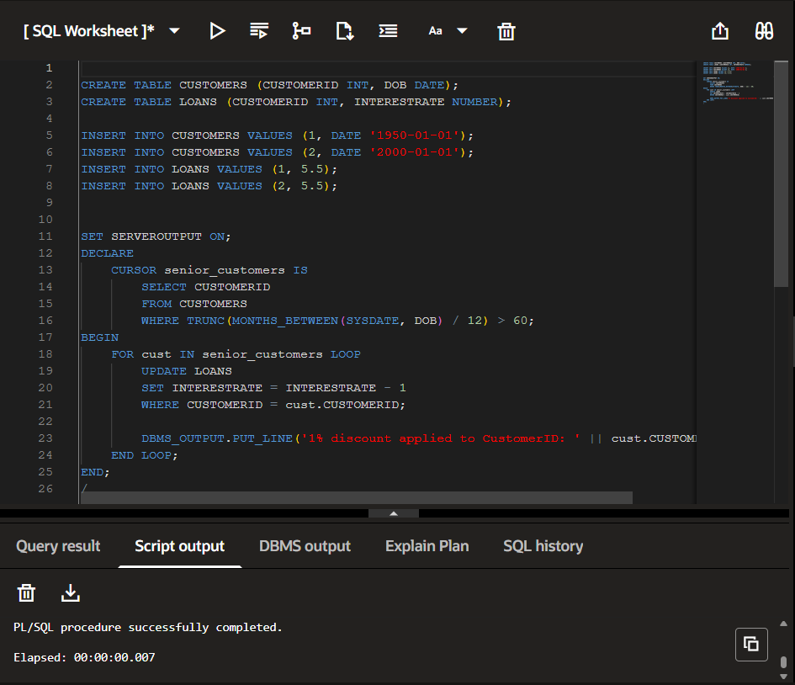

Scenario 2
SET SERVEROUTPUT ON;

DECLARE
CURSOR CUSTOMER_CURSOR IS
SELECT CUSTOMERID, BALANCE
FROM CUSTOMERS;
VAR_CUSTOMER_ID CUSTOMERS.CUSTOMERID%TYPE;
VAR_BALANCE CUSTOMERS.BALANCE%TYPE;
BEGIN
FOR CUSTOMER_RECORD IN CUSTOMER_CURSOR LOOP
VAR_CUSTOMER_ID := CUSTOMER_RECORD.CUSTOMERID;
VAR_BALANCE := CUSTOMER_RECORD.BALANCE;

IF VAR_BALANCE > 10000 THEN
DBMS_OUTPUT.PUT_LINE('CUSTOMER ID : ' || VAR_CUSTOMER_ID || ' HAS BALANCE GREATER THAN 10000');

UPDATE CUSTOMERS
SET ISVIP = 'TRUE'
WHERE CUSTOMERID = VAR_CUSTOMER_ID;
ELSE
DBMS_OUTPUT.PUT_LINE('CUSTOMER ID : ' || VAR_CUSTOMER_ID || ' HAS BALANCE LESSER THAN 10000');

UPDATE CUSTOMERS
SET ISVIP = 'FALSE'
WHERE CUSTOMERID = VAR_CUSTOMER_ID;
END IF;
END LOOP;
COMMIT;
END;
/
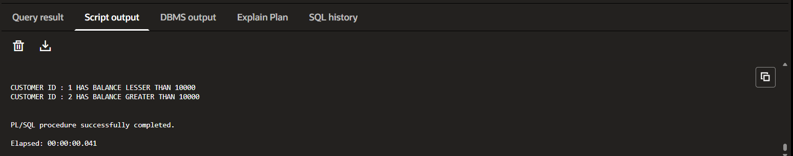
Scenario 3
